Organic Dairy Industry Survey Analysis

March 13, 2019

The overall objective of our project is to evaluate the association between bedding management practices and mastitis and milk quality outcomes on organic dairy farms in Vermont. A specific objective is to compare bedded pack management to other common housing and bedding management practices among organic dairy farms. Unfortunately, there is limited knowledge on the distribution and types of bedding management styles on organic dairy farms nationally or in Vermont.

Here we present data from a descriptive study (survey) designed to quantify the frequency of different housing types and bedding management styles on organic dairy farms in Vermont. Data from this survey will be used to design a future analytical study in order to estimate the association between bedding management styles and mastitis or milk quality outcomes. These survey results provide insight into the potential study design and pitfalls of different sample collection procedures for the future observational analytical study.

Goals of this industry survey were to (1) identify the most common housing/bedding strategy, (2) ask about other broad demographic factors that we thought might impact sample selection for the analytical study, and (3) assess interest in the future analytical study. There were 8 questions in the questionnaire, plus a request for farm location and contact information. All questions were optional. The questionnaire was mailed to all organic dairy farmers in Vermont and the mailing included postage paid pre-addressed return envelopes. The questionnaire was also available on-line. The on-line version was promoted through UVM web-sites and social media, as well as through regional industry publications. The online survey can be viewed at http://go.uvm.edu/nqamj. The questions in the on-line and mailed versions were identical. In addition, we conducted telephone interviews using the questionnaire for a subset of farms that did not respond to the first mailing, and we completed a second mailing to the remaining 83 farms.

Questions included:

1. Winter housing for lactating cows  
   Multiple choice (Free-stall, Tie-stall, Bedded Pack, or Other specified in comments)
2. Winter bedding for lactating cows  
   Multiple choice (Sand, Wood, Hay/Straw, or Other specified in comments)
3. Breed(s) of cow (open question)
4. Level of interest in the project (multiple choice)
5. Frequency of testing of *individual* cow somatic cell count, i.e. through DHIA  
   Multiple choice (more than monthly, about monthly, every other month, less frequently, never)
6. Experience managing a dairy farm in years (open question)
7. Experience managing an organic dairy farm in years (open question)
8. Average number of lactating cows (open question)
9. Farm name, Farm location, and contact person, phone number, email address, preferred time to contact

Our specific future research objective is to compare milk quality and mastitis outcomes on herds using bedded pack housing to other common housing and bedding management practices among organic dairy farms. Because herds using a bedded pack housing strategy are relatively infrequent in the source population, a simple random or systematic random sample design is probably not appropriate for our future analytical study. Rather, we propose to purposely select subsets (categories) of farms based on bedding management type and randomly select farms from within each category or stratum.

Given funding constraints and sampling logistics, we are targeting a total sample size of 40 herds for our observational study. **In the original grant proposal, we had proposed enrolling 10 organic dairy herds for each of four bedding/housing strategies: mechanically aerated bedded pack, static bedded pack, individual tie-stall, and individual free-stall housing systems.** However, these industry survey results suggest the bedding/housing categories should be reconsidered.

In the industry survey, we asked about a limited number of other factors to assess the frequency and variation in those that might influence milk quality and mastitis. For example, if in our 40-herd on-farm survey, we compare bulk tank somatic cell count (SCC) among four housing/bedding strategies but unbeknownst to us, all the herds using Strategy X have less than 5 cows, we won’t know if variation in their SCC is related to herd size or housing/bedding strategy. Furthermore, we would not know if Strategy X always has a very low herd size or if our sample group was by chance mostly very small herds. Though we can never fully control this issue, one way to achieve a balanced design when there are other factors that may influence our outcome measures is to randomly select the study population from a stratified sample population.

In this analysis, we have made suggestions for how to stratify the target population (Vermont organic dairy farms) to select a 40-herd sample that represents the goals of the research and controls potential sources of variation. **Please help us!** Any thoughts are welcome. Below, we highlight some "Action Items" where feedback would be especially helpful.

**Results**

The survey was mailed to 197 Vermont producers listed in the 2017 USDA organic database. The survey was additionally made available on the web and publicized in online newsletters and print newspapers. 121 Vermont farms responded (61% response rate) to the initial mailing. Responses to the secondary mailing are still being received. Three farms from outside of Vermont also responded. A total of 123 farms reported housing lactating cows.

Housing type and bedding material

The most common housing type was tie-stall (45%) followed by free-stall (32%) (Fig. 1). Most tie-stall producers used a wood-based bedding material, while free-stalls were split fairly evenly between sand and wood-based bedding. Bedded pack was a component of lactating cow housing on 16% of farms. Bedded pack was commonly used in conjunction with another bedded strategy (labeled “Bedded pack, Other” in Fig. 1). Nine farms reported using only a bedded pack for lactating cows. Most farms using a bedded pack bedded with wood, followed by hay or straw (Fig 1). The remaining farms (7%) reported a mixed tie-stall and free-stall system or a loose housing system (2 farms).

Anecdotally, we are aware that some farms rotate their lactating cows through multiple housing systems. For example, at least one farm milks cows in tie-stall barn, and a portion of the lactating herd may be housed in the tie-stall barn while the remaining herd is in a bedded pack barn. The cows on the bedded pack are then rotated into the tie-stall barn at milking time, so that within a 24-hour period, not all cows are housed on the bedded pack outside of milking time. In other herds milking in a tie-stall, the tie-stall milking barn is generally empty except during milking time, and in the winter, cows are housed on the bedded pack during all non-milking periods. Another potential complication is herds that have outdoor feeding access during parts of the day, where cows might be restricted from entering the bedded pack, or have access to both areas. The variation in the amount of time cows have access to the pack may influence outcomes among bedded pack herds. One option is to limit enrollment in the 40-herd study to bedded pack herds with limited variation in housing practices. For example, to be included in the sample for the subsequent survey, we propose that a screening phone call be used to assess the percentage of time that lactating cows spend on the bedded pack and use a cutoff threshold (we suggest 60% of non-milking time) to eliminate herds that use bedded packs less frequently. It is currently unclear how this criterion would affect sample size in the bedded pack stratum. Due to the number of bedded pack farms reporting (*n* = 20), we anticipate a stratification of bedded pack farms will not be possible, and all types will be included in the study based on the willingness of the famers to participate.

The “daily outdoor access” rule for animals on organic farms may add another complication. It is likely (mandated) that cows on organic dairy farms are not confined indoors 100% of the time regardless of housing system (i.e., free-stall and tie-stall herds may have access to outdoor feeding areas for some portion of each day). To understand the impact of this variation in the subsequent survey, we will need to quantify the variability in housing management and collect bedding samples from all areas where cows have lying/resting access during an average 24-hour period. This will result in collecting bedding samples from more than one cow housing location on some farms.

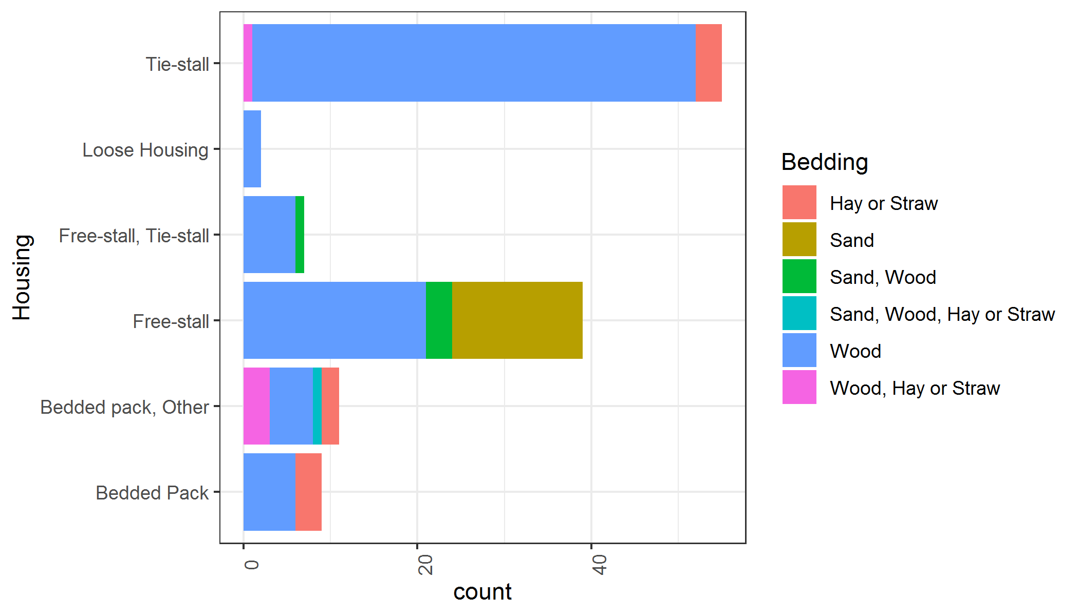

**Figure 1:** Bedding types in each housing strategy

**Action Item 1**: Feedback on experimental design – bedding strategy categories and size

We have identified that it may be difficult to enroll 10 herds each in two separate bedded-pack categories (static vs. aerated) as originally proposed. We suggest that the 40-herd survey include four housing/bedding strategies (wood-bedded tie-stall, wood-bedded free-stall, sand-bedded free-stall and bedded pack). We have debated how many farms of each group to include in the sample population.

* **Option 1:** Sample ten farms in each of the four strategies (total 40 farms) - wood-bedded tie-stall, wood-bedded free-stall, sand-bedded free-stall and bedded pack
  + **Pros:** balanced design with equally detailed information on each strategy, and may be easier to identify 10 bedded pack herds willing to participate
  + **Cons:** Fewer herds, and therefore potentially less information, in the bedded pack category and unsure if the variation among bedded pack herds will be affected by a sample size with fewer farms (10 versus 13 farms)
* **Option 2:** Sample 13 farms in each of 3 bedding strategies (wood-bedded tie-stall, free-stall, and bedded pack). Specifically, sample 13 tie-stalls, 13 bedded packs (with possible split between static and aerated), and 13 free-stall (with possible even split between sand-bedded and wood-bedded free-stalls) (total = 39 to 40 farms and possible uneven sample sizes in each category)
  + **Pros:** Larger sample size in each of the 3 broad categories.
  + **Cons:** Might result in treating free-stall category as a single management style; a sample size of 6 sand-bedded and 6 wood-product bedded herds might be insufficient to identify differences among free-stall herds using these two types of bedding, despite evidence in the literature that differences are likely to exist between sand and sawdust bedded free-stall herds. Similar for the split in bedded-pack herds.

Cattle Breeds

Breed distribution was similar across all housing bedding types, although bedded pack and sand-bedded free-stall producers were more likely to use Jersey and Jersey crosses (Fig. 2). There were four primary breed types: herds that identified as (1) Holstein only (2) Jersey only (3) mixed Holstein and Jersey herds with crosses or (4) mixed Jersey and Holstein herds with one or more additional breeds. We have debated whether and how to stratify based on breed.

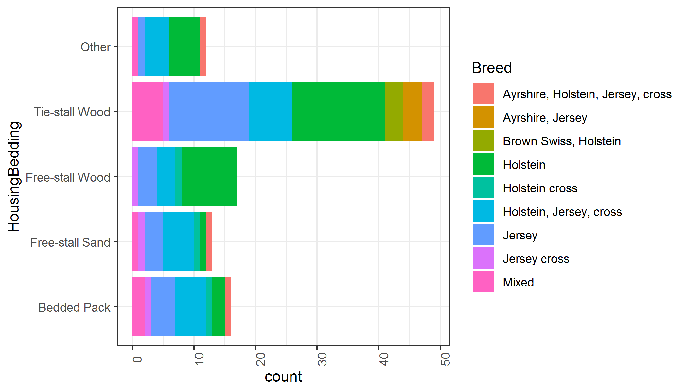

**Figure 2**: Breeds used in each housing bedding strategy. Only breeds that were used on more than 2 farms were included in the figure.

**Action Item 2**: Feedback on breed stratification

* **Option 1:** The 40-herd survey should include breeds in each housing/bedding category in approximate proportion to their use in the industry: 25% Jersey, 25% Holstein, 25% Mixed Jersey and Holstein herds with crosses, 25% Mixed Jersey, Holstein and other breeds with crosses.
  + **Pros:** Restricts breed to a measurable variable with a limited number of categories and might be possible to test breed associations
  + **Cons:** Loss of information about (and potential to enroll) herds that fall outside these categories, i.e., does not represent true variation in the industry
* **Option 2:** No stratification is performed and breed is left as an uncontrolled (but measured) variable in the data, but preference is given to herds that fall within the 4 categories mentioned above.
  + **Pros:** Fewer herds are excluded, making it easier to find participants
  + **Cons:** No control of breed variable, less power to compare variation among breed due to higher number of included breed categories, and some categories may have very limited numbers of subjects, ultimately requiring merging these herds into some larger category such as “other” if breed is to be considered as a predictor variable for mastitis and milk quality outcomes

A recent discussion with Dr. Stephanie McKay (UVM cattle geneticist) suggests ‘reported’ breed might be unreliable in these herds with cross-bred cows and confidence in understanding true effect of breed is questionable, suggesting we would record the information for descriptive purposes but not try to balance groups on breed categories.

Farmer interest in the study

Most producers (70%), including all but one bedded pack producer, indicated that they were either “Very” or “Sorta” interested in the results of the survey, suggesting that producers will be willing to participate in further research.

Use of monthly individual cow SCC testing

We are interested in enrolling herds that utilize monthly *individual* cow SCC because these data can be used as an objective measure of subclinical mastitis prevalence and incidence. We plan to collect data on farmer reported numbers of clinical mastitis events, but others have suggested these data can be less reliable than more objective measures such as SCC. Because organic dairy farmers are required to keep individual animal health records, it might be possible that farmer reported clinical mastitis cases are more reliable than have been previously suggested, and records may be available to collect these data from organic dairy farms. For the present, our primary outcomes of interest for mastitis prevalence and incidence will be based on measures of individual cow SCC available from DHIA records, and we will record farmer reported information on clinical mastitis incidence and prevalence noting if the response is from memory or written records.

Most (56%) producers reported an approximately monthly test of SCC for individual cows. We suggest that only farms using an approximately monthly test be included in the 40-herd survey. A potential pitfall of this approach is that farms using free-stall and sand were about 1/3 as likely to test approximately monthly and about twice as likely to never test SCC of individual cows (Fig 3). Only 3 sand-bedded free-stall producers test approximately monthly and thus if we preferentially enroll farms that use monthly SCC testing, we would have a small sample size among sand-bedded free-stall herds. Other farms (currently not on routine monthly tests) could be included in the survey to enroll more than 3 sand-bedded free-stall herds. However, we hypothesize that the farms enrolled in monthly individual cow SCC testing may differ in milk quality outcomes such as BTM SCC compared to herds that do not utilize such testing, and if this were true we are creating another source of potential variation due to monthly testing. One alternative would be to try to evenly distribute herds that do and do not conduct monthly testing across the 4 categories. Another alternative would be to enroll sand-bedded free-stall herds willing to temporarily enroll in monthly DHIA testing and compensate herds for costs to enroll. We suggest herds might temporarily enroll in order to get 3 months of DHIA SCC data to quantify subclinical mastitis prevalence and incidence for all enrolled herds. If we implement this second alternative, it might be to our advantage to enroll an equal number of herds in each of the 4 categories, where we add a transient period of monthly SCC testing, allowing evaluation of the possible association between routine use of monthly SCC testing (yes or no) and milk quality and mastitis outcomes.

Finally, a review of the answers given (including comments) suggests to us there may be some confusion among farmers interpreting whether or not they participate in DHIA SCC testing. Prior experience suggests some farmers might confuse bulk tank SCC testing provided by their milk cooperatives, the ability to submit individual cow samples for SCC testing through their milk cooperative, and subscriptions to DHIA testing services. Such confusion might explain the some of the variation observed in answers provided to this question.

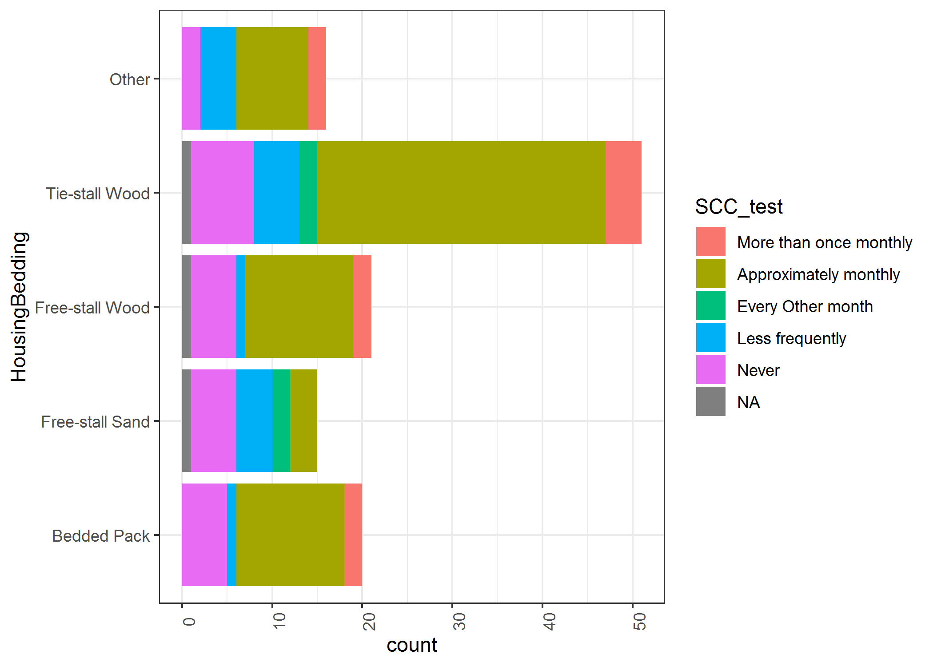

**Figure 3:** SCC testing of individual cows in each housing/bedding strategy. NA indicates no survey response.

**Action item 3**: Feedback on SCC stratification

* **Option 1:** Stratify by monthly SCC testing
  + **Pros:** accounts for potential use of monthly SCC testing as a mastitis and milk quality tool and allows us to test the hypothesis that this practice is associated with a difference in milk quality
  + **Cons:** further complicates stratification, and enrolling an equal number of herds that do and do not use monthly SCC testing may not be possible
* **Option 2:** Do not stratify by monthly SCC testing, give preference to enrolling herds currently using monthly SCC testing and temporarily subscribe to test through DHIA any sand-bedded free-stall herds that are willing to participate in study but do not use monthly testing. This would make monthly test results available for all herds
  + **Pros:** uniform data collection regarding monthly SCC for herds in all 4 categories
  + **Cons:** additional cost for enrolling herds in DHIA; sand-bedded herds not on DHIA testing and enrolled temporarily may still differ from sand-bedded herds regularly on DHIA testing – would need to account for this variation in analysis

Herd size

The median herd size among all dairies was 57.5 cows (Fig. 4). Producers using wood-bedded free-stall barns housed more cows than producers using either wood-bedded tie-stall, bedded pack (*p* < 0.05), and sand-bedded free-stall (*p* < 0.1). Despite this difference, the majority of producers using wood-bedded free-stall had a herd size that was similar to all other strategies. To reduce variation due to potentially randomly selecting from the extreme outliers for herd size, we suggest limiting participants by the number of cows to a range between the 10th and 90th quantiles (between 35-120 cows per herd). The majority of bedded-pack herds fall within this herd size.

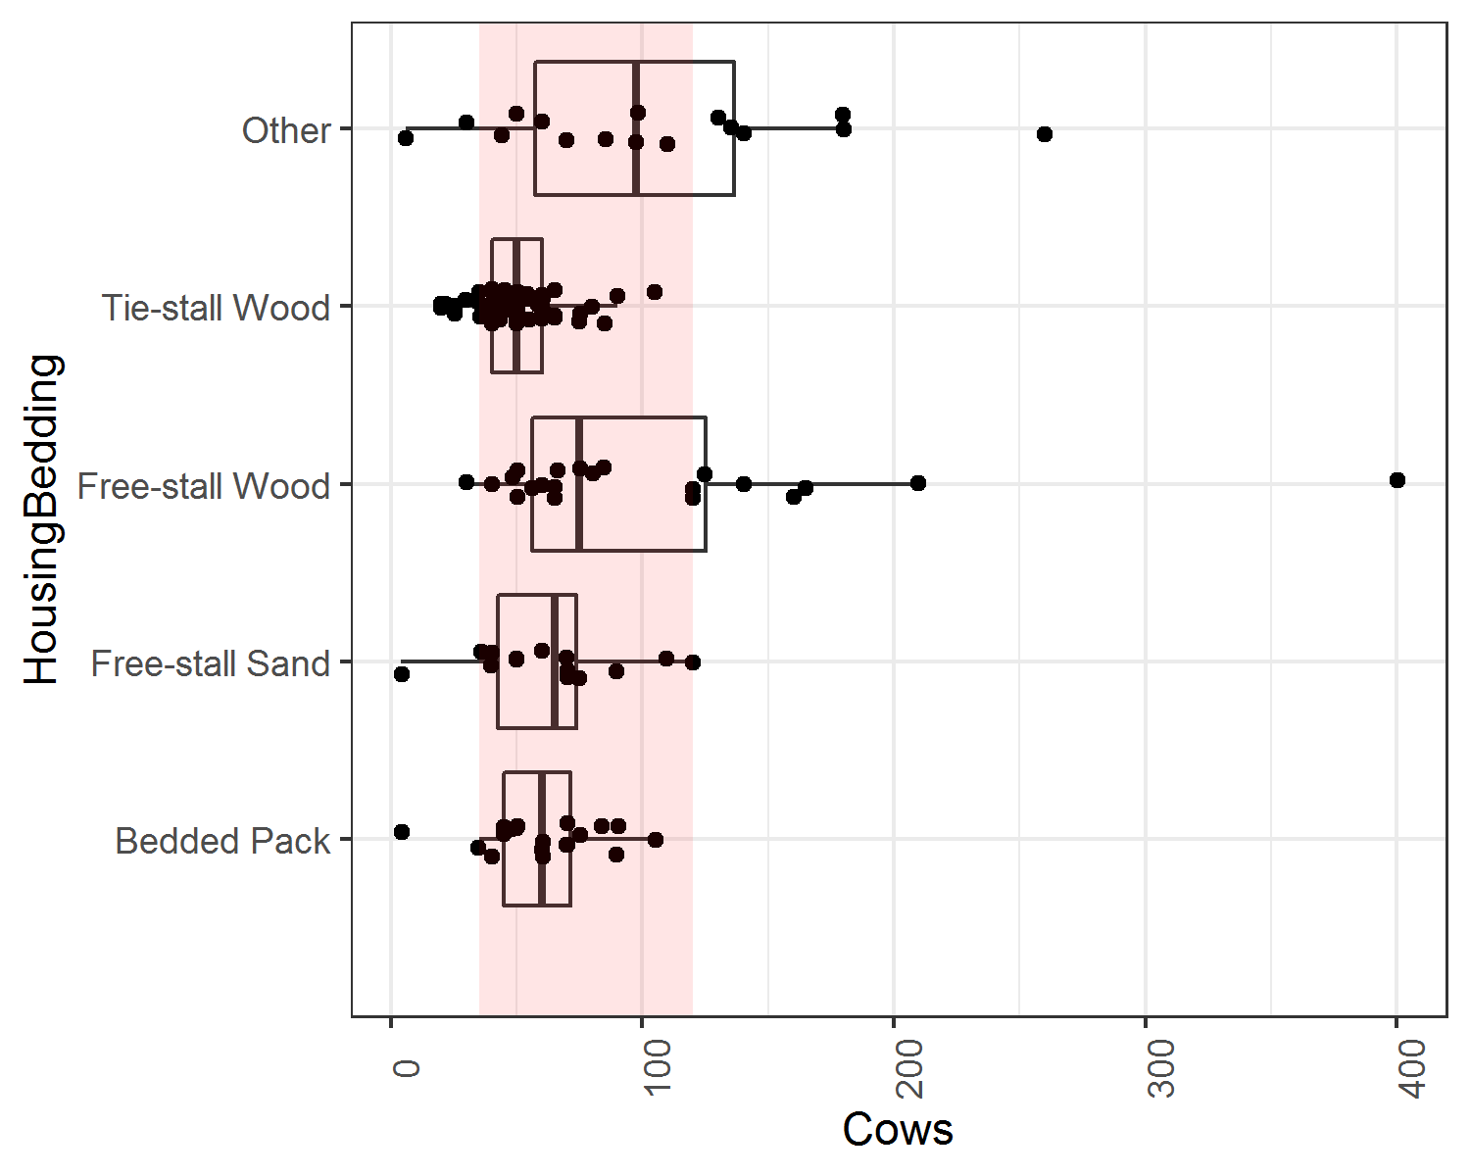

**Figure 4:** Number of cows varies among housing/bedding types. Pink band represents proposed herd size range for future sampling

Years of dairy farming experience

There was wide variation in experience in all housing bedding categories (Fig. 5). Years of overall management experience and organic experience were similarly distributed among housing bedding strategies, despite a narrower band of organic experience. There was no difference in years of experience (overall or organic) between housing/bedding strategy (*p* > 0.05). However, producers that used free-stall bedded with sand tended to have less experience, while producers using tie-stall bedding with wood tended to have the most experience. We suggest that because of minimal differences in experience among housing/bedding types, this factor is not used to stratify the population.

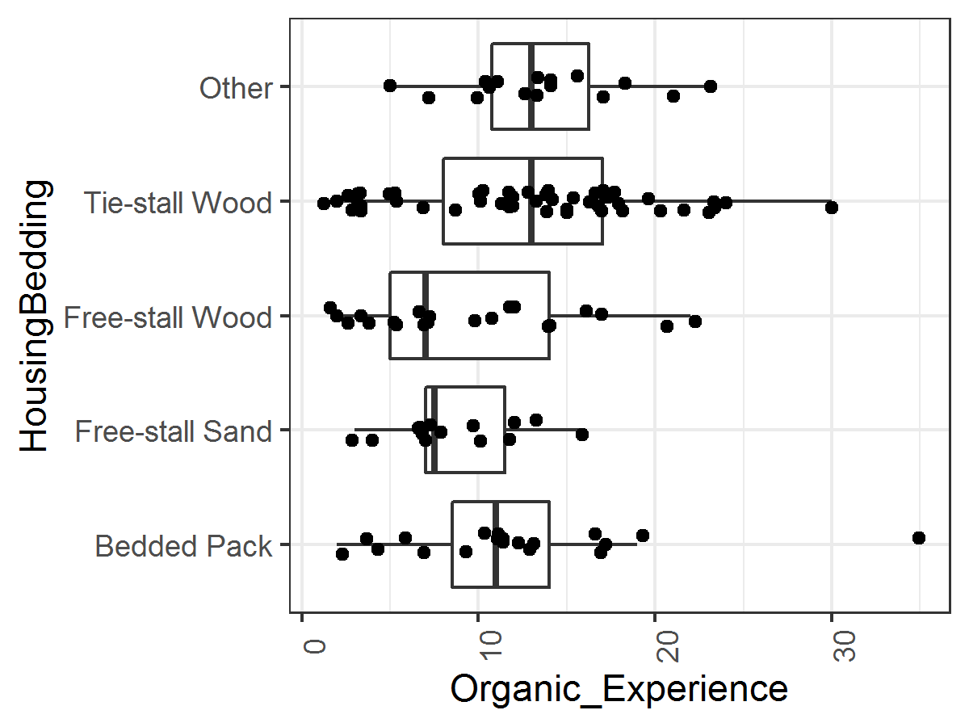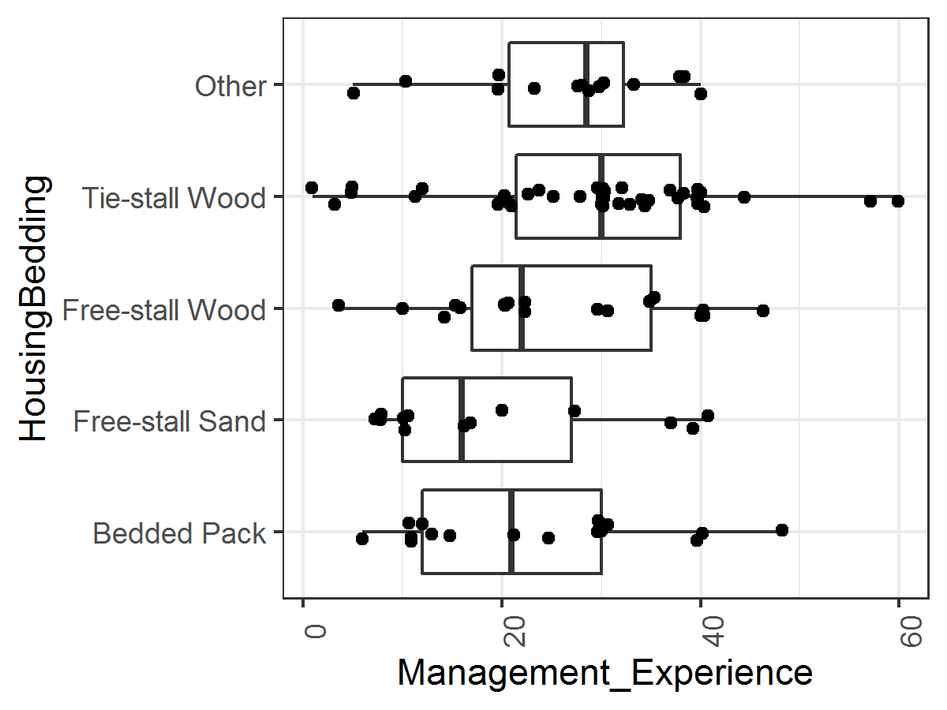

**Figure 5:** Relatively even distribution of management experience in each housing/bedding strategy suggests no stratification is necessary

Conclusion

In our initial industry survey, we have identified the frequency of bedding and housing management styles used on organic dairy farmers in Vermont (source population for future study).

We have identified 4 broad categories of housing/bedding styles with the greatest frequencies, including tie-stall housing using wood product bedding, free-stall housing with wood products, free-stall housing bedded with sand, and bedded-pack housing.

We have determined that bedding and housing management practices on herds using bedded pack style housing may be the most variable, and that it may be difficult to enroll 10 herds in each of 2 generalized bedded-pack management styles (static vs. aerated packs). Further, that “mixed” housing systems, where bedded packs are used in combination with another style are common, limiting the number of herds that we might enroll with a simple (pure) bedded pack housing design. Clarifying the extent of these mixed or hybrid housing systems and the reasons for their use might be an unintended direction of this project.

We have identified that some herd level characteristics such as routine individual cow SCC testing and herd size might be used as enrollment criteria, and others such as breed and years of farming experience might be too variable to use as stratification criteria prior to random selection of herds within source population subsets.

We have further defined the study design of our pending analytical study, which is perhaps best described as an observational cross-sectional study with a non-proportional, purposive sampling scheme. The unit of observation is the individual herd, with herds grouped by housing/bedding management category and each herd sampled once. We have developed a sampling scheme outlined in a flow diagram, which will be modified following advisor’s input (Fig. 6).

**Authors:**

Tucker Andrews, Plant and Soil science, University of Vermont, Tucker.Andrews@uvm.edu

Caitlin Jeffrey, DVM, Animal and Veterinary Sciences, University of Vermont, Caitlin.Jeffrey@uvm.edu

Deborah Neher, PhD Plant and Soil science, University of Vermont, Deborah.Neher@uvm.edu

John Barlow, DVM PhD, Animal and Veterinary Sciences, University of Vermont, john.barlow@uvm.edu

**Acknowledgements:** We thank Jennifer Colby and Juan Alvez for assistance with identifying organic herd mailing lists and developing the questionnaire and promoting the survey through mailing lists. We also thank Rachel Gilker for assistance with administering the survey by telephone with a selected group of producers, and Colene Reed for administrative support.

**Figure 6:** Herd enrollment flow chart (draft proposed)

“Largely” a non-probability purposive sample design with defined study criteria

Sequentially enroll randomly selected herds from each group until sample population of willing collaborating herds is identified – during recruitment call confirm factors such as monthly individual cow SCC testing, and winter housing variation. Consider adding additional herds not on DHIA but willing to temporarily enroll for study

Tie stall herds

Free stall herds

(sand bedding)

Free stall herds (wood bedding)

Bedded Pack herds

Initial Study sample population

Randomly select from each group

Stratify on housing/bedding type

Source population

Organic Dairy farms In Vermont

herd size 35 to 120 lactating cows and test through DHIA

Exclude herds not on monthly DHIA

Source population

Organic Dairy farms In Vermont

herd size 35 to 120 lactating cows

Exclude very small and very large herds

Target population

Organic Dairy farms In Vermont